Logo 
Wireframe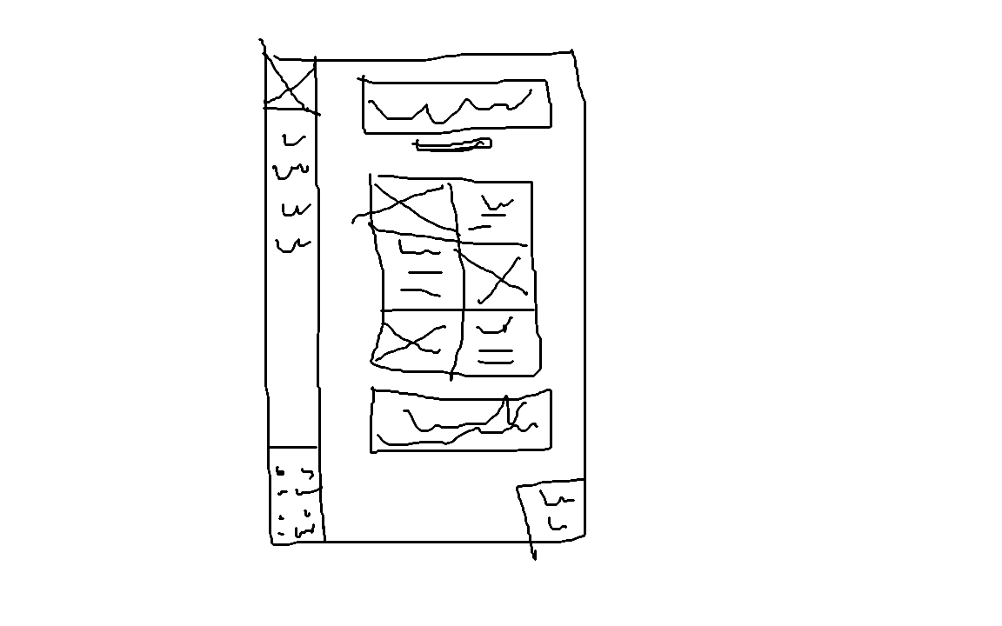
Color Scheme
#0B2118
#415730
#F9EACC
#685947
#68806D
#E9AB37

Fonts:
Armatic SC
Edu QLD Hand
Merriweather
Special Elite

